**CAPSTONE – DATA PROCESSING – CAR EXTERIOR DAMAGE ASSESSMENT**

Guidelines to Annotate :-

Tool – VGG Image Annotator tool

Step – 1 :

Python file - capstone_data_processing .py : Used to rename the img and json files , copy it to appropriate folders.

#GLOBAL VARIABLES DECLARATION

FILEPATH = '/content/drive/MyDrive/Capstone/capstone_data' [Could be done on local machine too)

PROCESSED_DATAPATH = '/content/drive/MyDrive/Capstone/capstone_data/data_processed'

USER = 'TG'   #[KN, PV, RT, PK, TG] User Initials

SOURCE = 'cotrn5'

#Possible sources - to be decided before starting a new batch :: [cotrn, coval, cotst, gtrn1, gval1, gtst1, web1, web2, ......]

#img_input folder : Takes the raw images and it is to be placed in /capstone_data folder. Upload the batch of image files in the img_input folder.

Step – 2 :

Run the cell which has been marked. Instruction will be on screen. A new folder will be created of the format - <SOURCE>_<USER>_DateTime. Inside this folder , all the files from “img_input” folder will be copied and renamed.

Now, download this folder on your local hard disk.

Step – 3 :

Open VGG VIA in browser.

a) Click on ADD Files and select the files from the downloaded folder that has the renamed files.

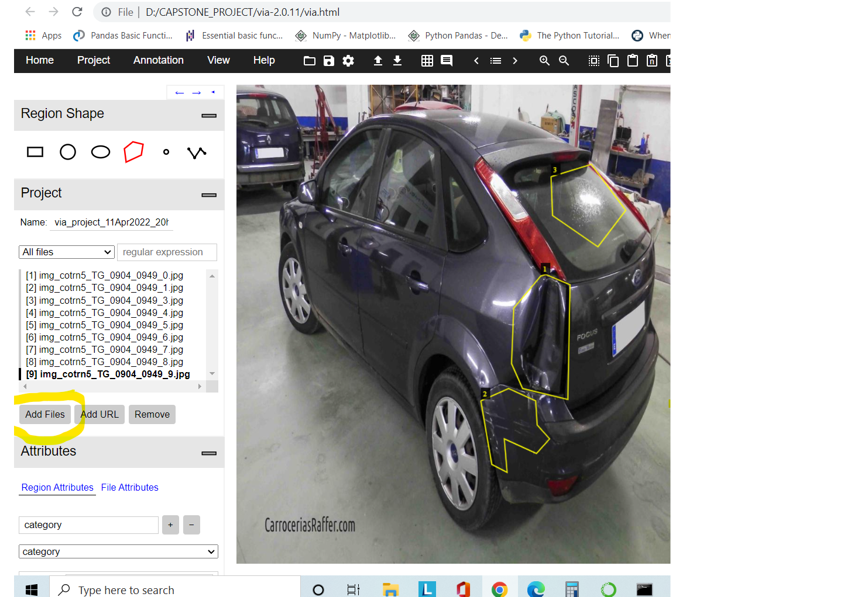

b) Next, add Region Attributes – Click on the + button and add ‘category’ in the text box. Subsequently, add Type as Drop Down that’s the easiest to select. Then add Sub-categories : - scratch, dent, glass-shatter and smash. Note – “ glass-shatter” : hyphen not an underscore. Maintain the order for consistency.

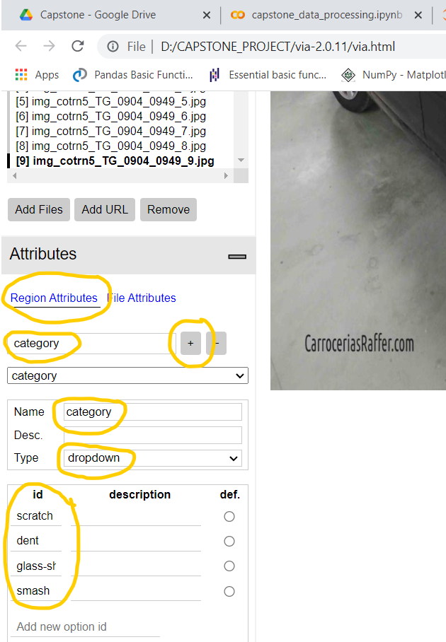

c) Now, start annotating the files. Click on the polygon button and draw boundary co-ordinates around the damage. Kindly draw the bounding boxes in such a way that the damage edges are distinctly seen so annotate outside the edges.

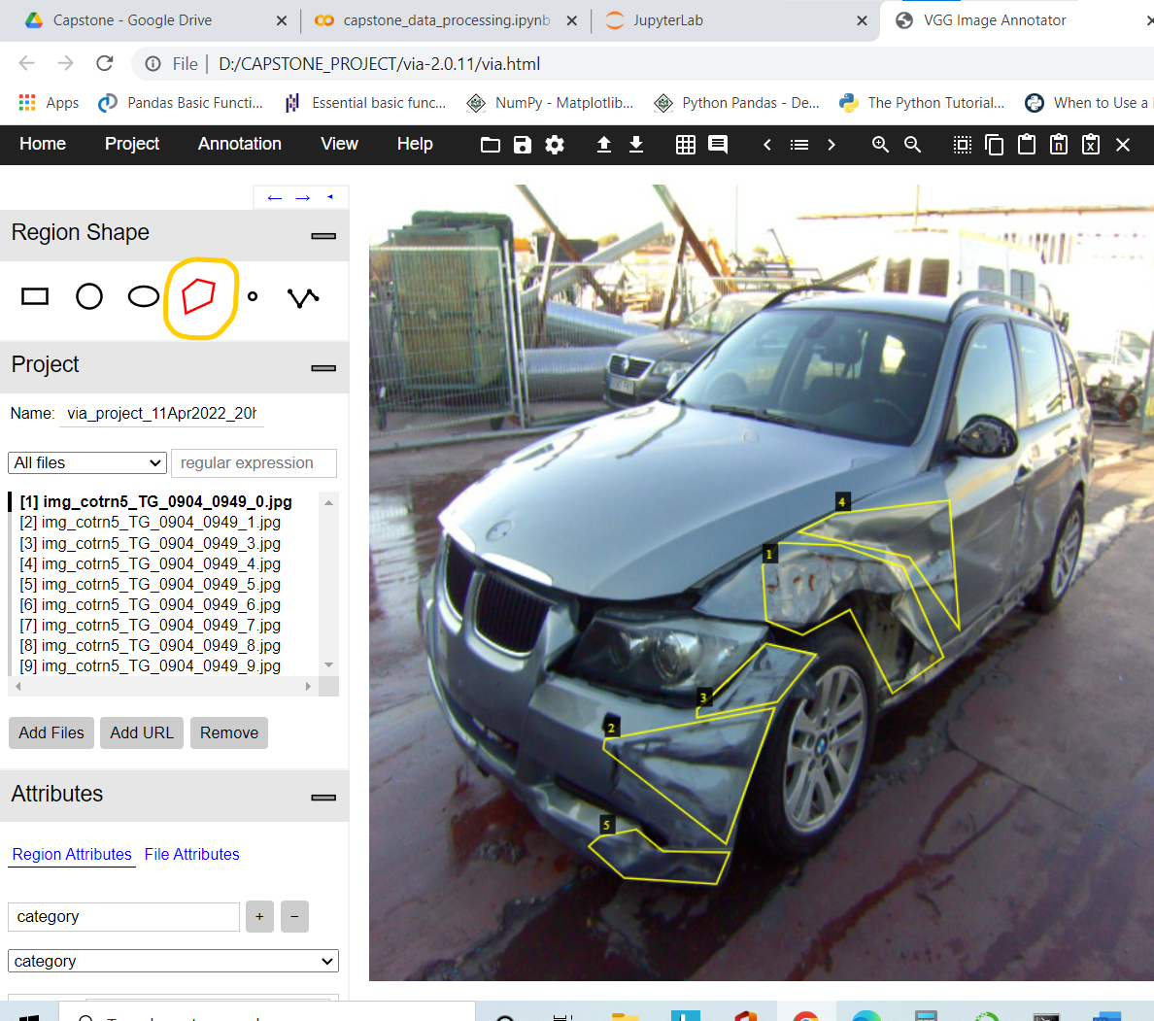

d) Select the categories for all the bounding boxes.

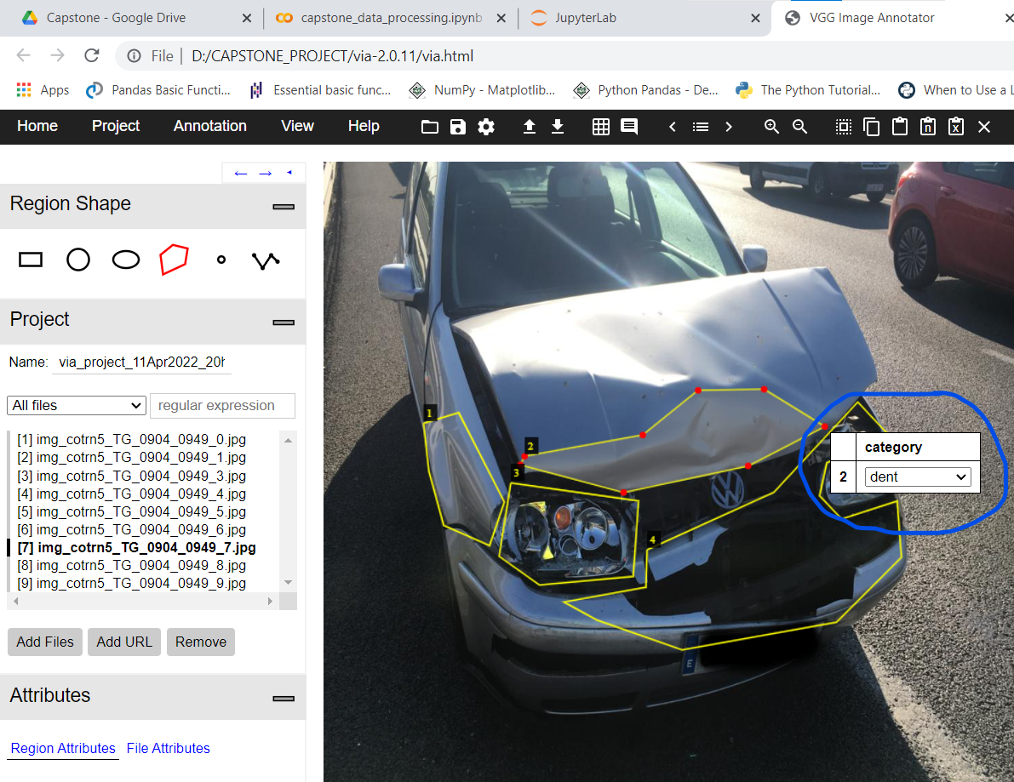

e) Once completed, check whether all the bounding boxes categories labelling has been properly marked. Lastly , SAVE the project file by clicking on the button. Keep the selection as its is and click Ok. File names will be like - via_project_11Apr2022_20h12m and will be automatically downloaded.

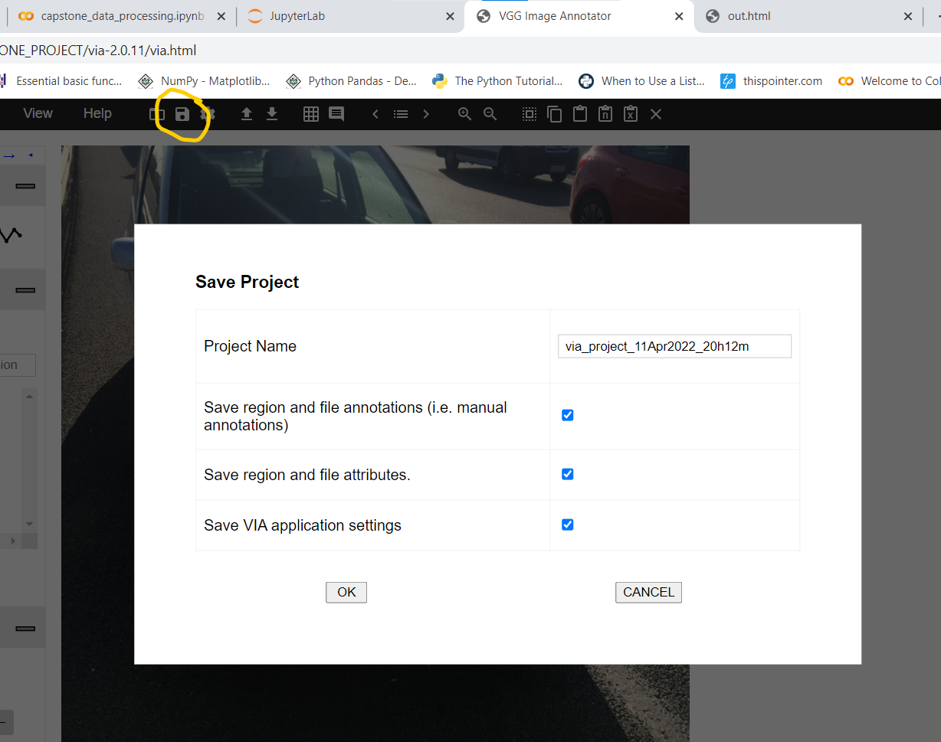

f) RULES FOR ANNOTATION and Visualization of annotated images :-

VISUALIZATION: Annotated files could be downloaded using the VGG VIA tool. Sample Annotated File downloaded from VGG VIA.

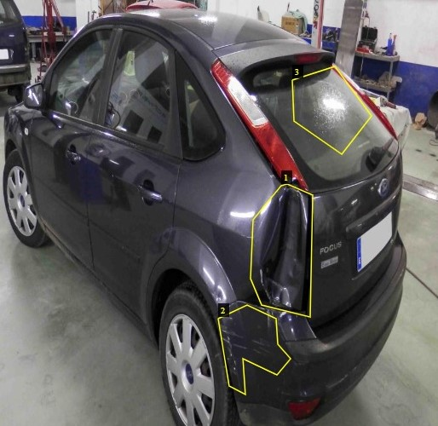

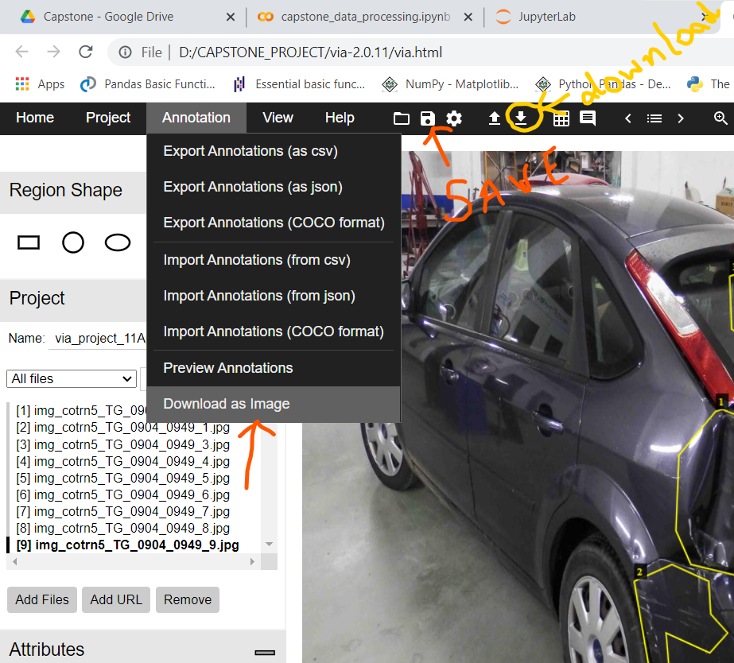

As mentioned, Download as Image, will download the IMAGE WITH ANNOTATIONS, one at a time. TEDIOUS PROCESS,

CAUTION - The YELLOW marked button will download Json file with annotations in a format DIFFERENT FROM THE FORMAT WE GET WHILE WE CLICK ON SAVE button.

VISUALIZATION TOOL :

RITHVIK’s DASHBOARD will help to visualize the annotations and troubleshooting.

2 Python scripts – car_labelling.py that needs to be executed which in turn calls DashboardGenerator2.py

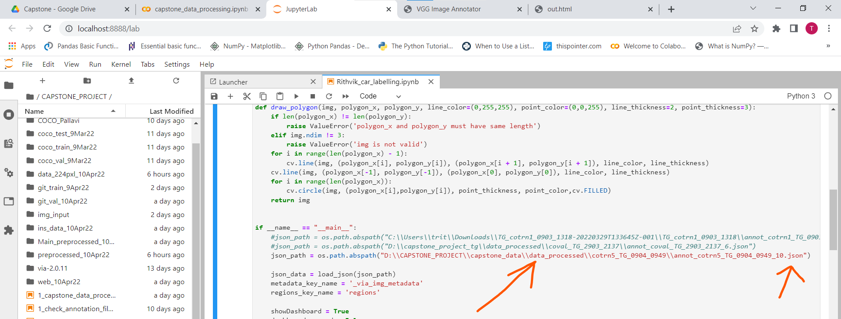

Provide the path to the JSON file along with the Image files and run the cell to open the annotated files in HTML.

After every batch of annotation, ensure to run it to check if all categories that were marked is showing up.

PROBLEM FACED with missing boundary boxes post saving – I had to redo 2 batches again because, categories were not marked even after saving. So, run the dashboard to be CERTAIN.

Dashboard Visualization of Images for COCO – Train – Batch 5 ::

Fig – A :-

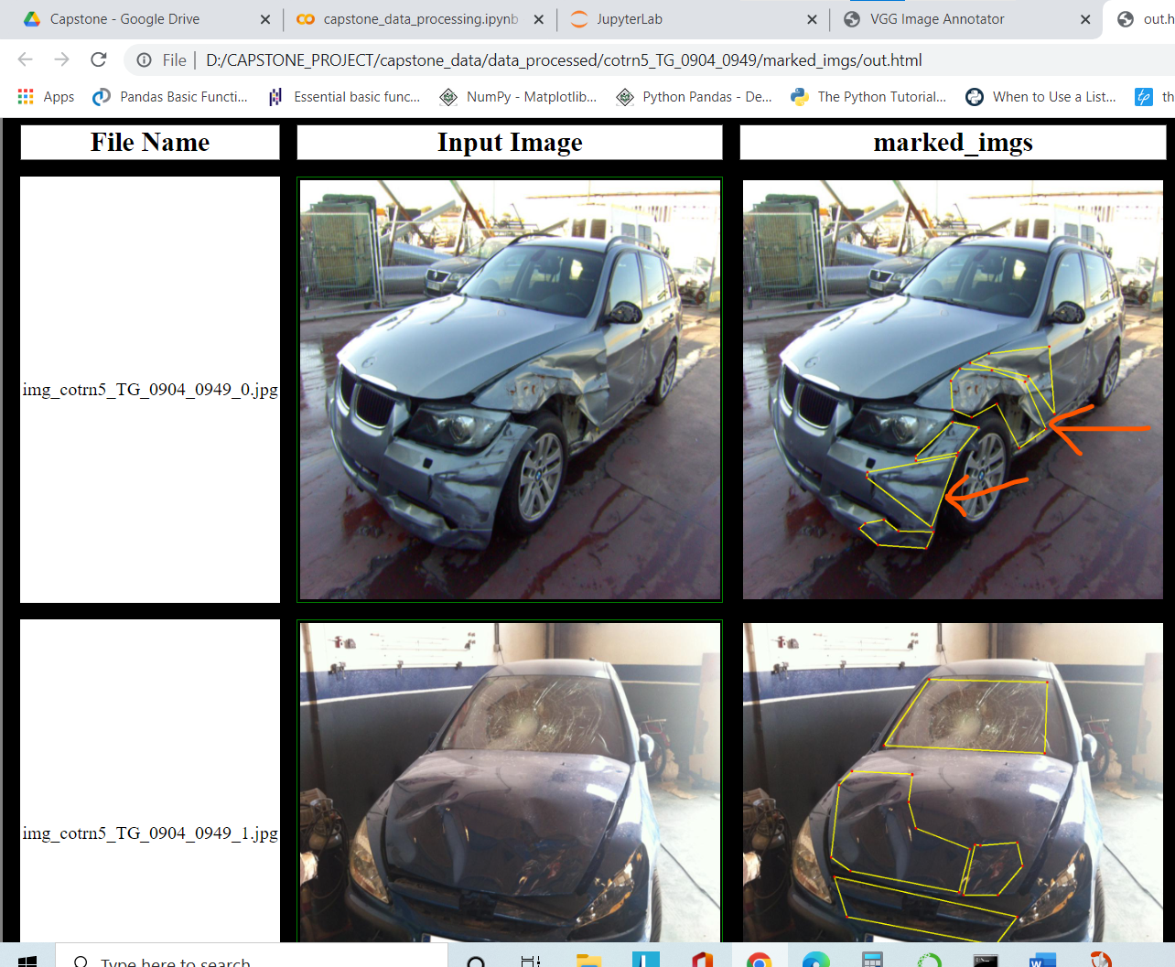

Fig A1 - First image :: Scratch could be seen but its fully fall inside a larger dent . So, category marked – DENT

Fig A2 - Second Image :: Multiple dents , smash and scratch are marked. If there exist multiple category, even if it is a smash, highlight the other categories as well

IMP – The model needs to understand the pattern, hence follow the same consistency throughout.

Fig A3 - Whenever , DENTS or SCRATCH is marked, ensure that the PATTERN is clearly distinguishable. Hence, edges must be kept inside the annotation box. For that, if a slight more space could be taken around the damaged area.

The following figure explains the same. Slope of the DENT is distinguishable.

Fig A3 -

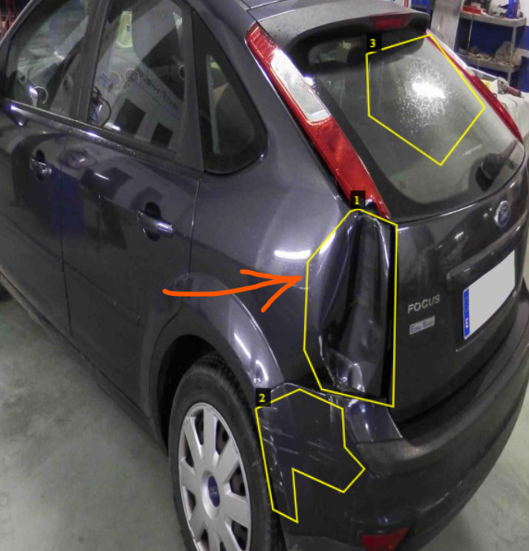

Fig - B :-

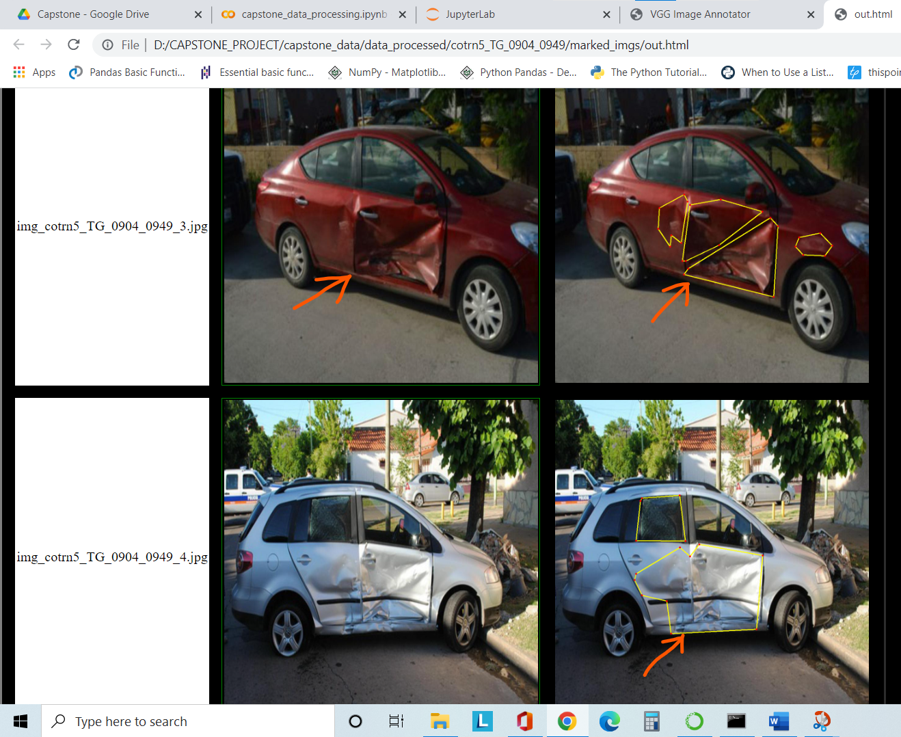

Fig B1 – Red Car : The bigger region has been marked into DENT and SMASH/CRACK. The entire region could be considered as SMASH, on case basis (When smash is more dominant than DENT)

Fig B2 – White Car : Marked as DENT for the entire damage.

Fig - C :-

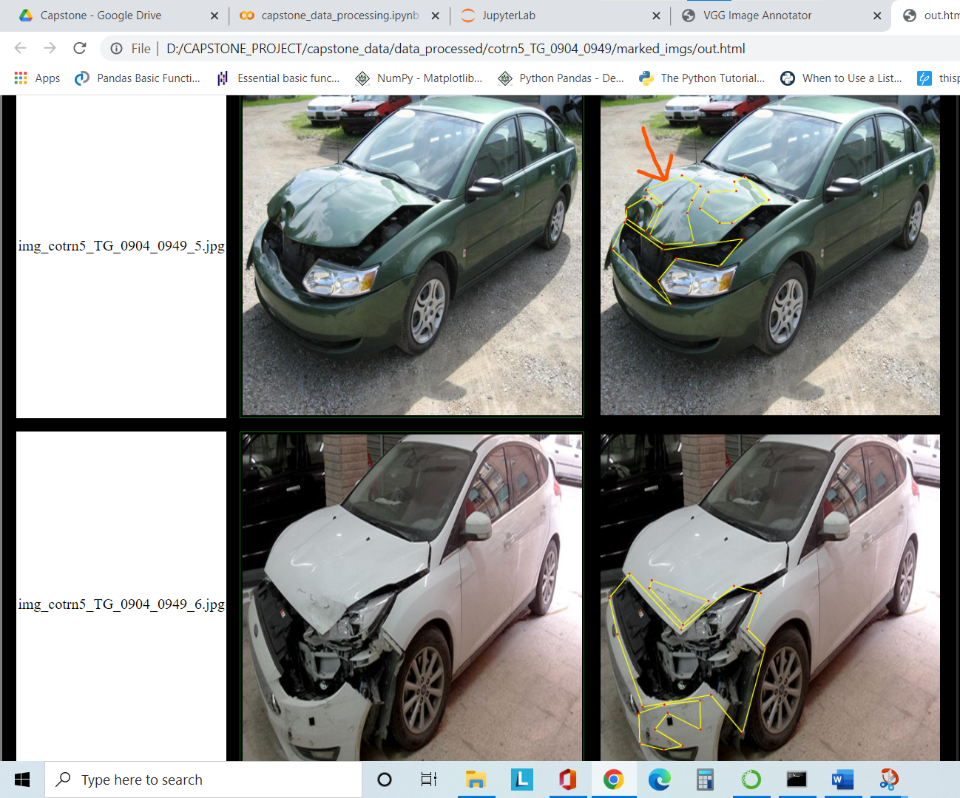

Fig C1 - The arrow marked category has been marked SCRATCH, even though, the surrounding areas were under DENT. But since, scratch was quite visible so SCRATCH was marked.

Fig C2 – White car has been marked as SMASH and 2 SCRATCH. DENT is also present, but not very distinguishable.

Fig – D :-

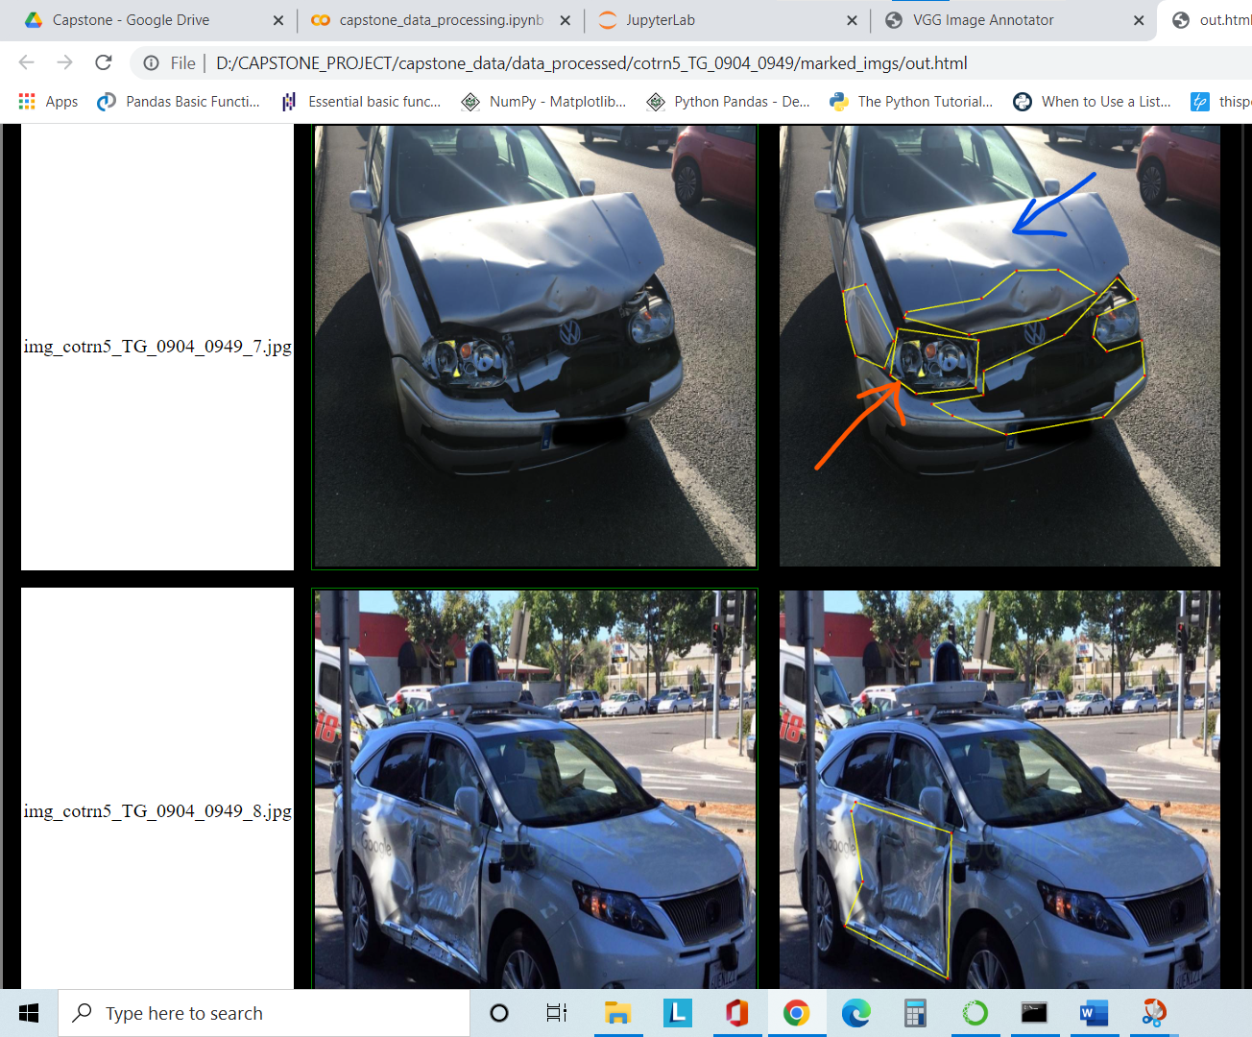

Fig D1 - The RED arrow marked category has been marked GLASS-SHATTER. There are many images, where head light glass is broken slightly. Those categories CANNOT be termed as SMASH unless the surrounding area of the headlight is bulging out.

The BLUE arrow is a DENT but its reflective hence NOT marked.

Fig D2 – White car has been marked as DENT and NOT SMASH because in SMASH category, the car’s body sheet should be coming off / torn / broken.

Step - 4 :

POST – Annotation – Copy the Json file like via_project_11Apr2022_20h12m .json to “IMG_INPUT” folder with the original images. Run the second cell in capstone-data-processing.py . This will rename the json file, move all the img and json file from “captone/ capstone_data / img_input” to “captone/ capstone_data / data_processed” folder and delete the img_input folder.

OPTIONAL :

***Issues faced – Duplicates removal is not easy but once we start annotation, we would remember the files. While annotating, incase we realize that the file has already been annotated OR you are doubtful of how to annotate OR resolution of image is bad, then

1. DELETE the file if it’s a duplicate

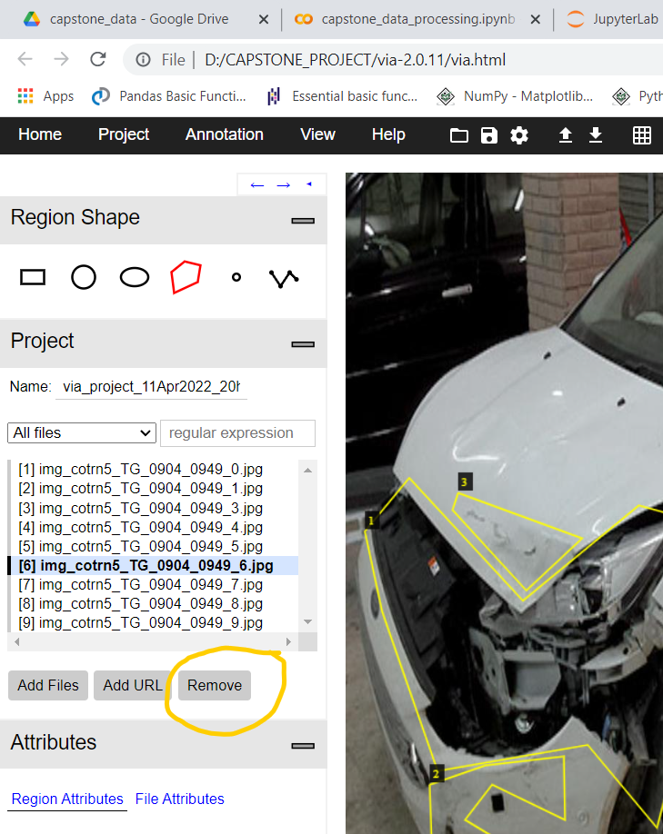

1. If it isn’t then SIMPLY OMIT THAT IMAGE. The Json file will NOT feature the omitted image.

FURTHER CHECKS implemented to ensure consistency and avoid human errors – Python script check_annotation_file_map.py. This file will

1. **To check the files mentioned in Json exist on disk** : - Read each JSON file across folders / sub-folders and create a dataframe – “df_annot” with the corresponding Image files. Those files physical existence on disk will also be checked and flagged to 1 if exist else 0.

Dataframe looks like –

Data columns (total 8 columns):

# Column Non-Null Count Dtype

--- ------ -------------- -----

0 folder_idx 63 non-null int64 – FolderId same for a batch

1 filename 63 non-null object – Img file names / Json

2 size 63 non-null object – Json attributes

3 regions 63 non-null object – Json attributes

4 file_path 63 non-null object – Img file path

5 json_filename 63 non-null object – Json file name

6 img_exists 63 non-null int64 - [ 1/0 ]

7 json_exists 63 non-null int64 – [ 1/0 ]

Snapshot of data -

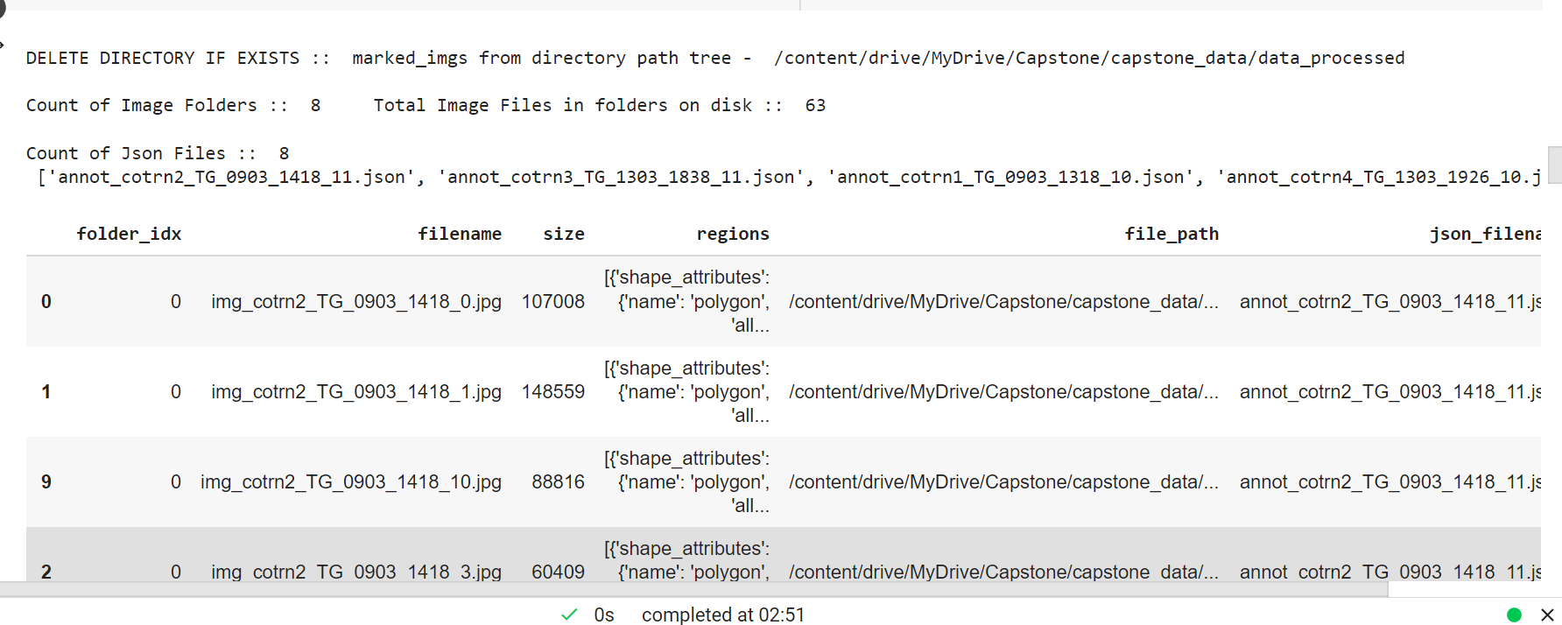

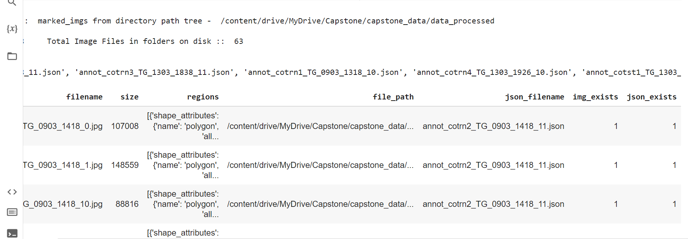

**As seen, status of all Img and Json files = 1 which means ANNOTATED FILES EXIST in the corresponding folder.**

1. **To check the files present in the folder were annotated** : - After checking the Json files, it will check the folders for physical files and if the data matches with the JSON file. Incase, there is a mismatch the ERROR ANALYSIS will reveal the same. It will return a dataframe – df_map which will have data with respect to physical files and their differences, if any will be highlighted.

As mentioned above, that while in the process of annotation if we omit a file by choice or by redundancy then EITHER FILE COULD BE REMOVED or KEPT BUT NOT ANNOTATED. In such case, the discrepancy will be highlighted. The folder TG_cotrn5_0904_0949 has a file named img_cotrn5_TG_0904_0949_2.jpg, which was omitted as it was duplicate.

The Error Analysis shows that there is a mismatch between physical file count and corresponding Json file annotated. It means, FILE WAS NOT ANNOTATED.

Snapshot –

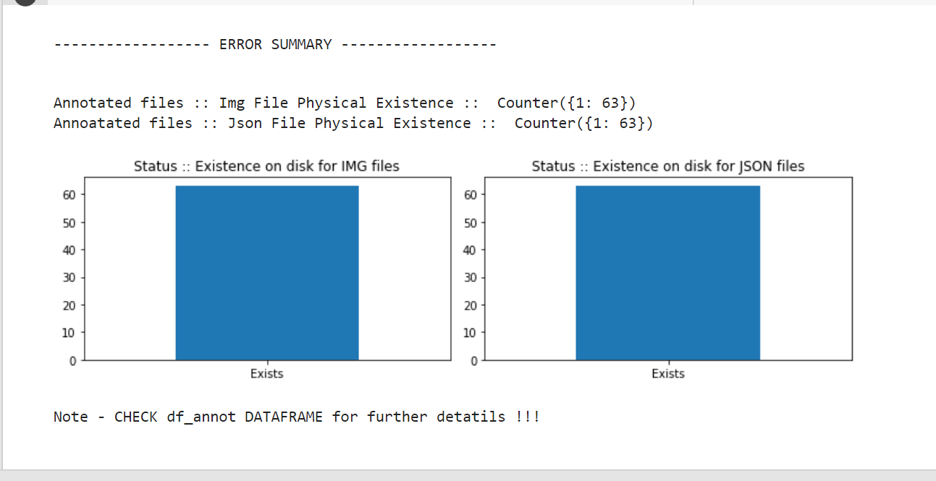

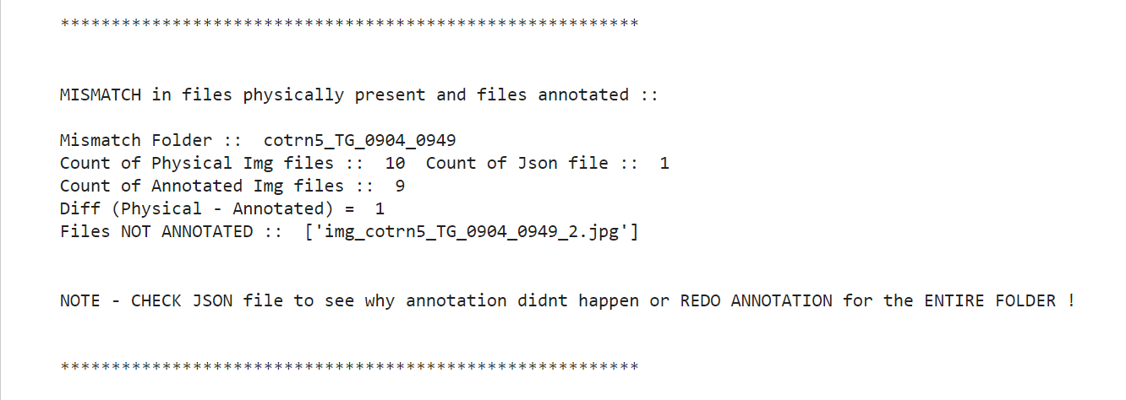

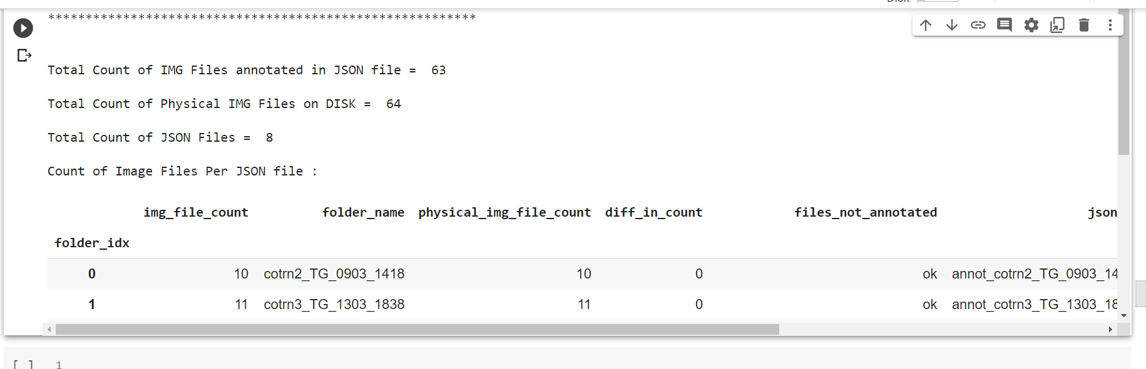

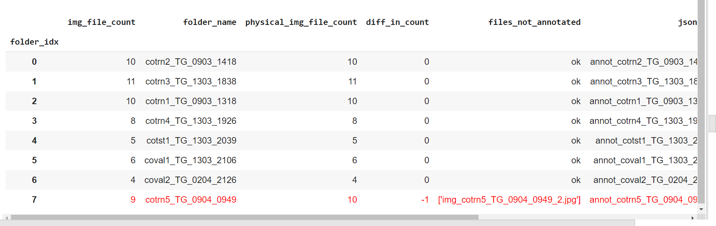

Dataframe df_map will highlight the records with mismatch.

1. Next, the script will move the UN-ANNOTATED files in a separate folder under /capstone/capstone_data . This folder could either be considered for annotation or could be deleted. Snapshot of the last operation –

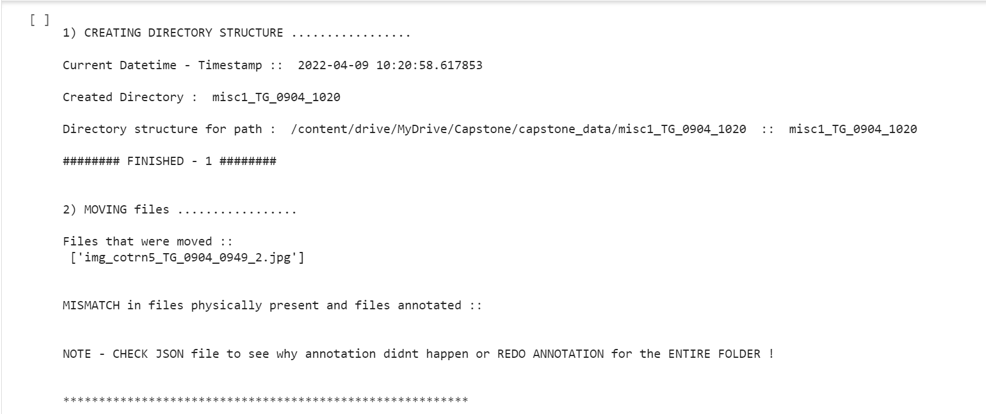

Final df_map would show : 0 diff in count

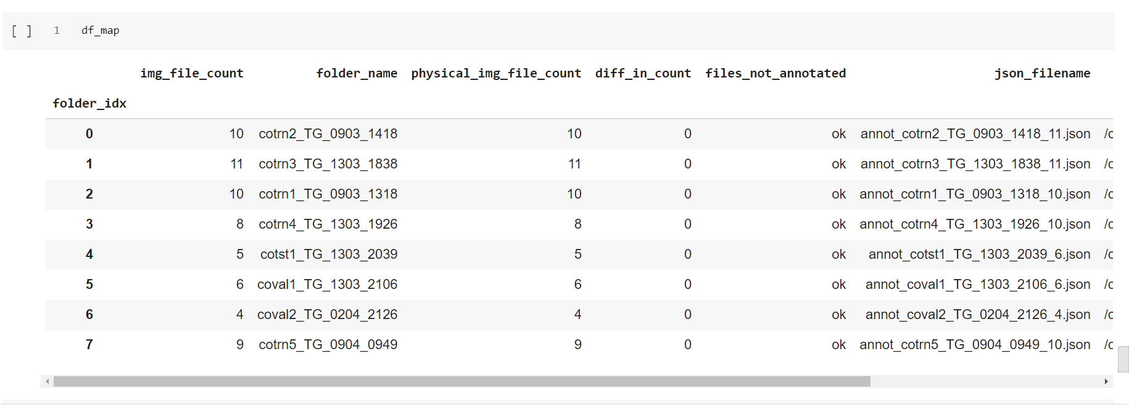

***This script is executed using Run All and at the end can view the status. This script could be used to ensure annotated and physical file mismatch doesn’t happen. Can be executed after few batches of annotation.***

Another script for Batch creation of Image files – Batch_Generator.py : Will create batches of images from directory tree . Could be used, if required.

CONFIRMED DATA : Total (minus doubt) = 1211 DATA_224pxls = 1512 (not checked)

COCO – 70 GITHUB – 955 INSURANCE – 86 WEB – 100 DATA_224pxls – 1512

WEB ongoing : 1000 approx

ANNOTATED : COCO - 70